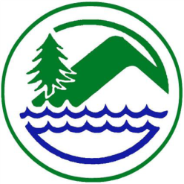
West Fork Conservation District

February 14th, 2024 @ 10:00 AM
USDA Service Center
Mount Clare, WV

10:00 A.M. Call to Order
Pledge of Allegiance

Welcome and Introductions:
M Approval of Agenda
D/M Approval of Minutes of January 10th, 2024, Board Meeting
D Cooperating Agencies Report
NRCS, FSA, Forestry, WVU Extension Service, WVACD Exec. Dir.
Financial Reports
M District Bookkeeper General & CDO Funds Report/WVCA Restricted Funds Report
M Supervisor Per Diem & Travel
M Approval of Invoices & Payments:
D/M
Unfinished Business

D/M AgEP Program
Payments:
Kevin Britton Well Dev. $5,000.00
Cancelations/ Withdrawals: None Currently
Conservation Agreements:
Stella Donaldson Lewis Count Acres 131.5
D/M OM&R Polk Creek & Salem Fork
D/M Dam Inspection Reports
Old Business:
D/M
D/M

New Business

D/M Correspondence - None currently
D/M Funding Request- None Currently
D/M Letters of Request – None Currently
D/M Soil Sampler Advertisement
D/M Beef Expo
D/M SSRP/EWP Project-
D/M Board Member, Associate Supervisor, and Committee Reports

WVCA/District Employee Report
WVCA – Kaitlyn Jones, Devon Kokoska, Dee Altman
WFCD Jennifer Metheny
Public Comments
Adjournment

Upcoming Meetings and Programs:
Board Meetings:

March 13th, 2024 @9:00 AM Mount Clare, WV
April 10th, 2024 @ 9:00 AM Mount Clare, WV
May 8th, 2024 @ 9:00AM Mount Clare, WV

Office Closed on Following Dates: February 19, 2024, President’s Day

Check Day February 15th & 29th, 2024.

