Eastern Panhandle Conservation District
SUPPLEMENTAL BOARD MEETING
June 5th, 2024, 10:00am
AGENDA
Call to order
D/M Truck privileges
D/M Dress code
D/M Discussion/Motion for amount of money being spent that needs to be approved. $1,000 or $500?
D/M Kory Harmison lives out of state, per policy guidelines supervisors must live in state and be a landowner
D/M Attorney

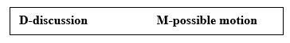
Adjourn

