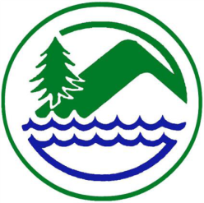

West Fork Conservation District

Special Board meeting

December 6th, 2024

USDA Service Center, Mount Clare, WV

10:00 A.M. Call to Order
Pledge of Allegiance
M Approval of Agenda

D/M Pasture Renovation Project/ MOU
D/M LOR to Request Pasture Renovation Funds
D/M Scholarship Donation/ WVACD $1,000.00
Date of Next Meeting
Wednesday December 11th,2024, USDA Office, Mount Clare, WV 10:00 a.m.

Adjournment

