Meeting Minutes
Supervisors Present: Supervisors Absent:
Linda Brown – Braxton County Jeremy Cantrell – Clay County
Larry Greynolds – Nicholas County Debbie Hamric – Braxton County John Pitsenbarger-Nicholas County
Mike Smalley – Webster County
Keyota Jarvis _ Clay County
*Clark Mollohan – Webster County

* Appeared by Phone/Teams

Others Present:
Dylan Johnson: WVCA, Kirk Burroughs: ECD, Jack Spencer: WVDOF, Russell Young: NRCS, Chris Ellison: WVCA and Barbie Rader: AS-ECD. * Devon Kokoska WVAC Area Director, Andy Sentz-NRCS, Shirley Hyre-Associate Supervisor and Debbie Friend- WVU extension.

Call to Order
The meeting was called to order at 9:34 am by chairman John Pitsenbarger. The Pledge of Allegiance was led by Shirley Hyre.

Agenda
Larry Greynolds moved to accept the agenda as presented. Linda Brown seconded the motion, motion carried.

Minutes
Linda Brown moved to accept the minutes of the February 24 and March 10, 2026 meetings. Keyota Jarvis seconded the motion, motion carried.

Treasurers Report
Linda Brown moved to accept the Treasurers Report and file for audit. Larry Greynolds seconded the motion, motion carried.

Payment of the Bills
Larry Greynolds moved to approve the addition of Robinson Sales and Services bill for $5,325.00 to the list of bills to be paid, Linda Brown seconded the motion, motion carried. Linda Brown made a motion to pay the bills presented in the new amount of $5,796.72 Larry Greynolds seconded the motion, motion carried.

Old Business:
- Dylan Johnson gave an update on the Salt Lick Rehab Project.
- Barbie Rader reported the progress of the tree sales.
- Funding for Envirothon- Mike Smalley made a motion to spend up to $2,000.00 to the teams competing in the Envirothon .

New Business & CORRESPONDENCE
- Smart Farms grant was discussed along with the purchase of the reseeding of the projects. Larry Greynolds made a motion to write and LOR for Brandon Kyper for $40,000.00 from the Smart Farms Grant. Linda Brown seconded the motion, motion carried.
- Land judging will be held June 4th at Nettles Equipment land. Larry Greynolds made a motion to purchase lunch and awards for the students participating, up to $500.00. for lunch. Linda Brown seconded the motion, motion carried.
- Larry Greynolds Made a motion to make the land judging contest the “H.K. Skidmore Award. Linda Brown seconded the motion, motion carried.

- Larry Greynolds made a motion to pay the expenses of Shirley Hyre during the Envirothon. Linda Brown seconded the motion, motion carried.

- Keyota Jarvis made a motion to approve the following AgEP. Larry Greynolds seconded the motion, motion carried. :

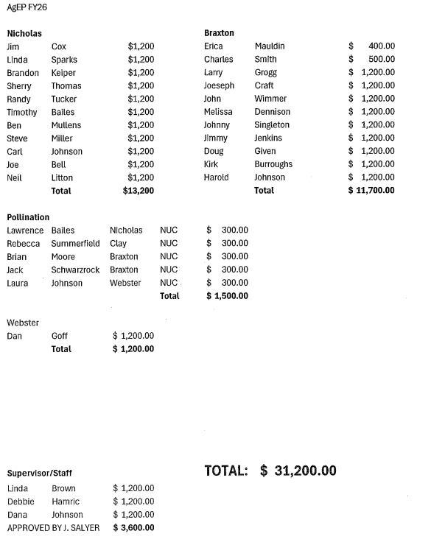
Reports

Reports
Reports were given by : OM&R,WVCA District Operations Manager, WVACD, WVU/WVSU Extension, WVDOF, NRCS and ECD Supervisors.

Adjournment

Adjournment
On a motion made by Keyota Jarvis and seconded by Clark Mollohan; Chairman Pitsenbarger declared the meeting adjourned at 11:54 p.m.
Minutes Approved April 28, 2026
________________________
Larry Greynolds, Secretary

